Machine Learning Assignment 3

Part 2:

1)

**Linear Accuracy =**97.67% (586 correct, 14 incorrect, 600 total). Precision/Recall: 96.43%/99.00%

**Polynomial Accuracy** = 97.33% (584 correct, 16 incorrect, 600 total) Precision/Recall: 95.81%/99.00%

**RBF Accuracy =** 97.33% (584, 16 incorrect, 600 total) Precision/Recall: 96.43%/99.00%

2)

**Fold 1, Accuracy:** 97.25%

**Fold 2, Accuracy:** 96.75%

**Fold 3, Accuracy:** 98.00%

**Fold 4, Accuracy:** 97.75%

**Fold 5, Accuracy:** 96.00%

**Average Accuracy: (**97.25 + 96.75 + 98 + 97.75 + 96)/5 = 97.15%

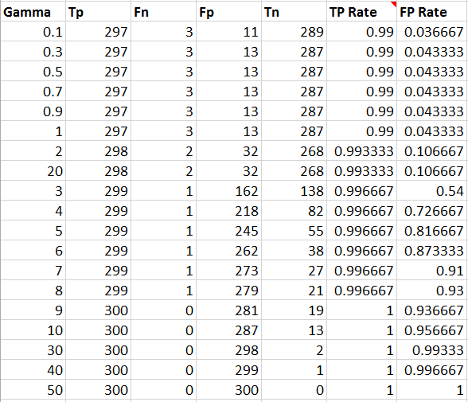3)

Based on the ROC results, the best Gamma is at 0.1 as it is the closest to the top left corner which is represents a perfect predictor. Because the TP rate falls in a very small range close to 1, the graph looks skewed a little with the Y-Axis starting at .988. When adjusted to start at 0, it is obvious that Gamma at 0.1 is the best choice.